CENWP-ODJ 7/24/2023

MEMORANDUM FOR THE RECORD

SUBJECT: 23JDA29 Sockeye and Chinook Morts in Gatewell 12B

On Friday 21 July 2023, at approximately 0800, JDA fisheries personnel found an adult sockeye mort and 11 Chinook subyearling morts in gatewell 12B. They were removed from the gatewell, scanned for PIT tags (1 subyearling had a tag, see below) and returned to the river. JDA fisheries had operations switch MU12 to a last on/first off operation until further investigation the following week. On Monday 24 July JDA fisheries removed 12 Chinook subyearling morts from MU12B, they were scanned (no tags) and returned to the river. MU12B is the same gatewell that back in May, the orifice slide gate had broken off from the shaft and blocked the opening, leaving no egress route from the gatewell, and this is suspected to be the problem again. The gatewell was dipped to remove any additional fish, and approximately 400 smolts were removed and released into the forebay. MU12 is currently out of service and the gatewell will be dewatered this week to address the problem.

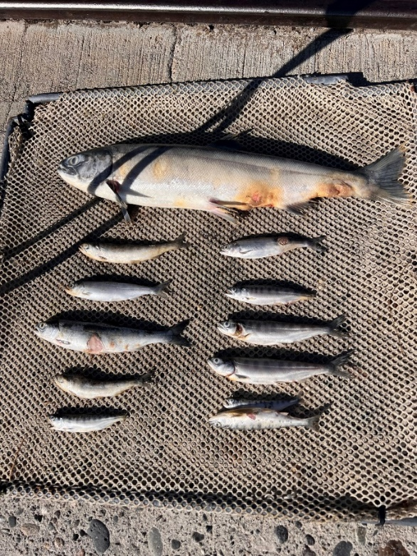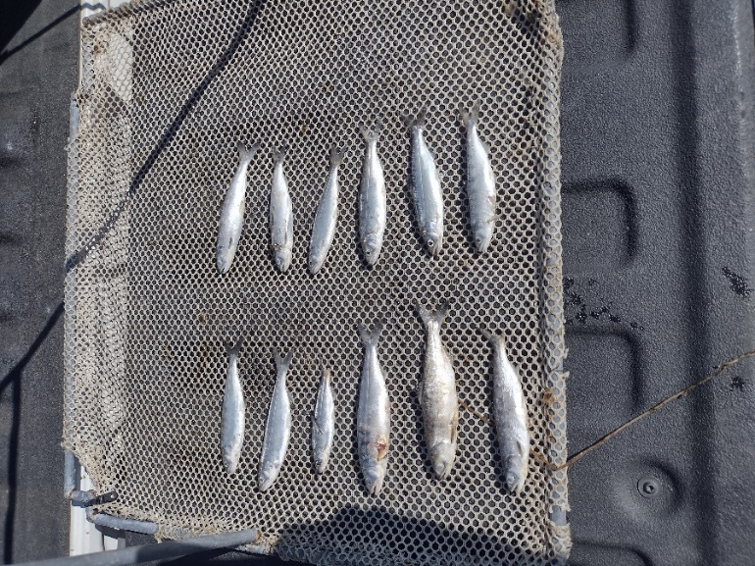

- Species – Sockeye and Chinook subyearling
- Origin – Unclipped and clipped
- Length – Various
- Marks and tags – Clipped Chinook subyearling- 3DD.003E4B6505
- Marks and Injuries found on carcass – Some descaling, fungus
- Cause and Time of Death – No egress route
- Future and Preventative Measures – Debris loads are light so JDA fisheries will keep the orifice open in local mode to prevent this from happening again until the problem can be properly addressed during the winter maintenance period.
Sincerely,
JDA Project Fisheries

